PC configuration utility installation guide

Site Sync

Document history 2

1 Introduction 3

2 Installation of SSL certificate 3

2.1 Importing the SSL certificate in the certificate store 3

2.2 Reservation of the URL for DCU 9

2.3 Adding the SSL certificate 10

3 Installation of PC configuration utility 11

# Document history

|  |  |  |
| --- | --- | --- |
| **Revision** | History | Date |
| 1.0 | First draft version | 07th April 2014 |

# Introduction

This document explains the process of setting up the machine for running the PC configuration utility. The document is divided into two sections:

1. Installation of the SSL certificate.
2. Installation of the PC configuration utility.

We will be installing the SSL certificate on the PC. The certificate is created at Maven and the same certificate will be copied to all the PCs. Before performing any of the following steps, unzip the setup file PCUtilityV-XX.zip shared by Maven.

# Installation of SSL certificate

The certificate installation activity is a one-time activity for the machine on which the PC configuration utility will run. This is required for the PC configuration utility to communicate with the DCU using SSL.

## Importing the SSL certificate in the certificate store

Following steps are for importing the SSL certificate in the certificate store.

1. Go to the Start menu of windows. In “Search programs and files” text board enter “mmc.exe” and open it. A console user interface will open which is shown below.

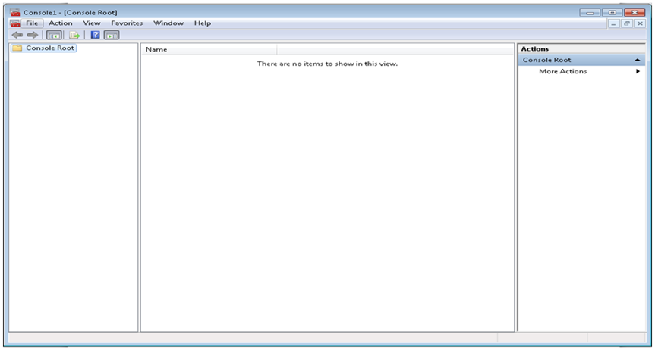

1. Go to “File” menu and select “Add/Remove Snap-in”.

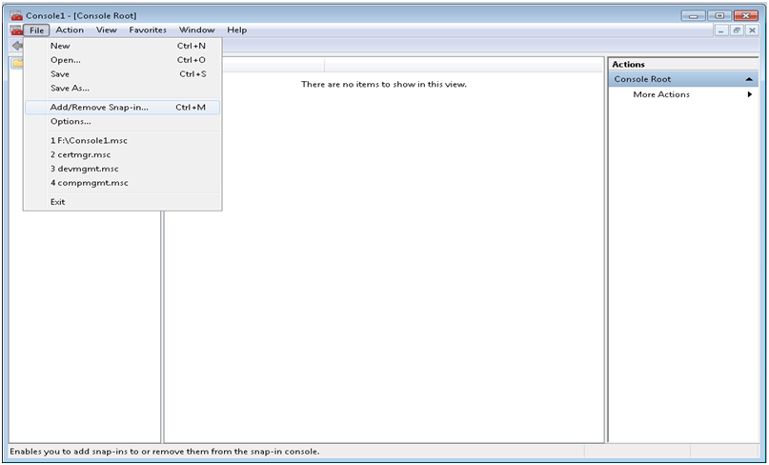

1. From the “Add or Remove Snap-in” dialog box popup, from the left panel select “Certificates” and click “Add >”.

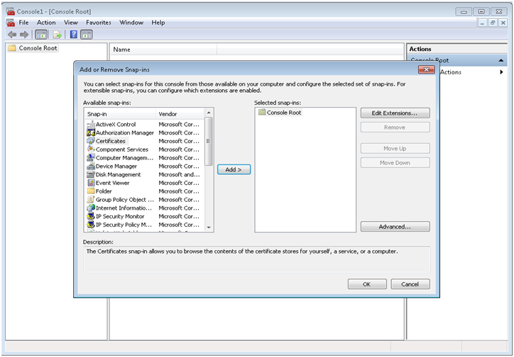

1. From the “Certificates snap-in” dialog, select “Computer account” and click “Next >”.

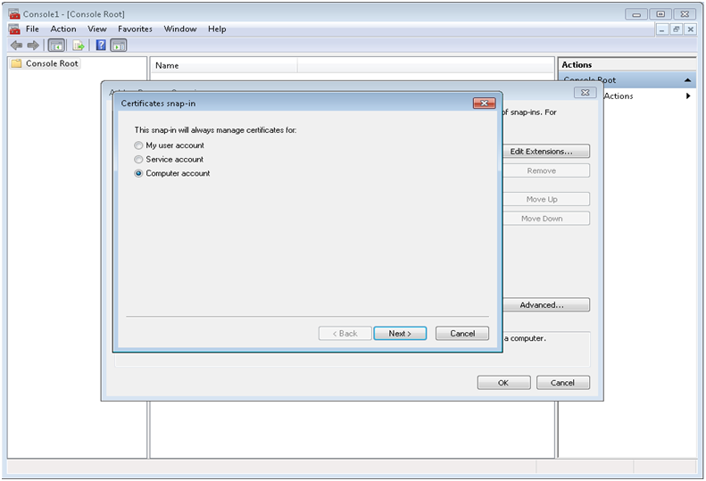

1. From the “Select Computer” dialog, select “Local computer” and click “Finish”.

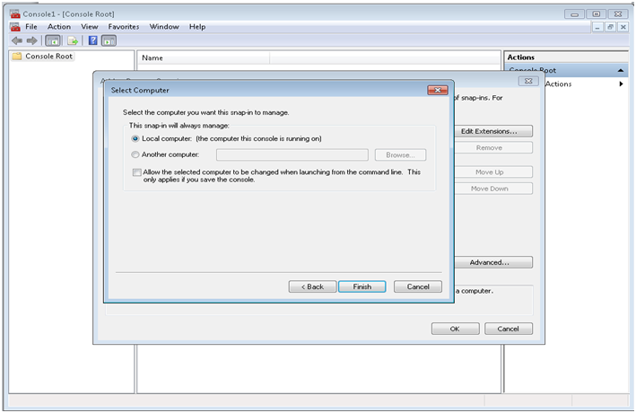

1. In the console root panel, right click on “Personal”, go to “All Tasks” and then click “Import”.

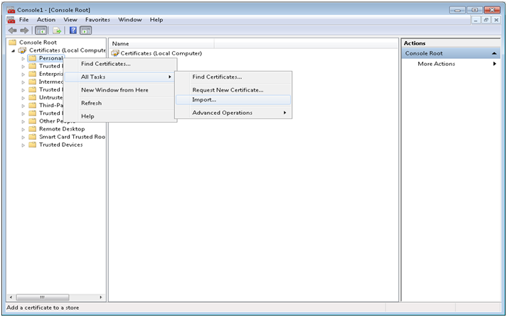

1. Browse the SSL certificate (.pfx file) in the setup folder which is unzipped earlier and click “Next >”.

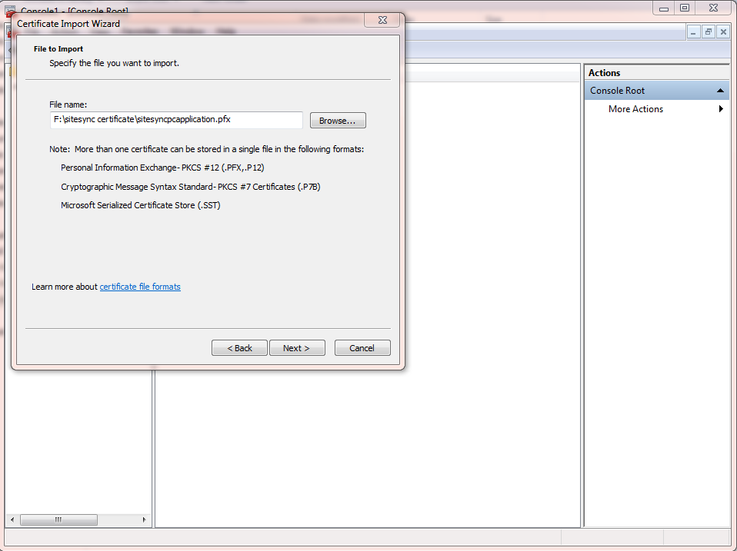

1. Enter the password which is “123456”.

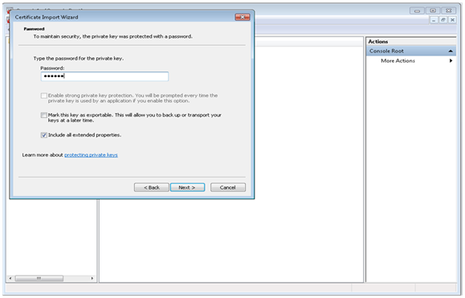

1. The store in which certificate will be stored is shown. Click “Next >”.

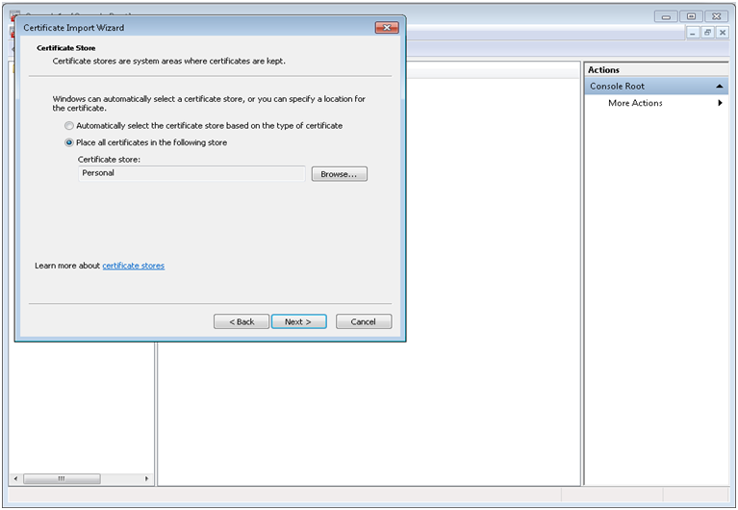

1. Complete the certificate import wizard by clicking “Finish”.

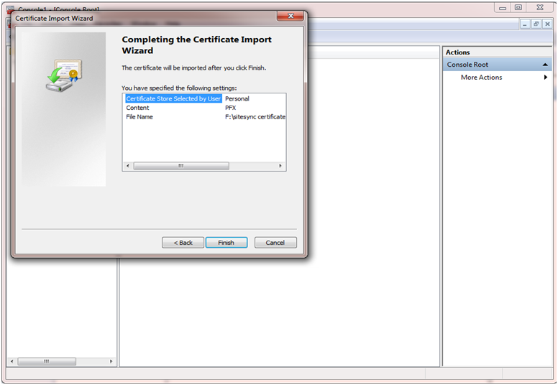

1. After importing the certificate successfully, below popup appears which states “The import was successful.”

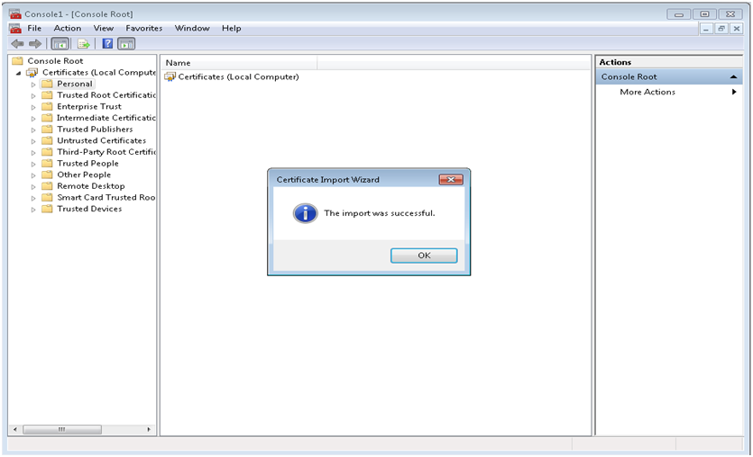

## Reservation of the URL for DCU

This step is for the reservation of the URL for DCU to communicate with the PC configuration utility using this reserved URL. Open command prompt using administrative privileges. Execute the command “**netsh http add urlacl url=https://+:4443/ user=enter your machine’s username**”. The message “URL reservation successfully added” will be displayed.

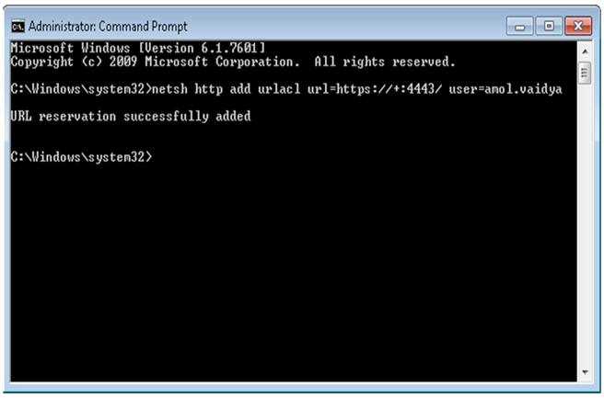

## Adding the SSL certificate

This step is for adding the SSL certificate for the PC configuration utility so that utility will be able communicate with DCU using this SSL certificate.

From the opened command prompt, execute the command “**netsh http add sslcert ipport=0.0.0.0:4443 certhash=eceb09d43e166415ebd4a25c77d840b94a7cbed3 appid={e59259b3-49c4-46de-9a53-77859a397785}**”.

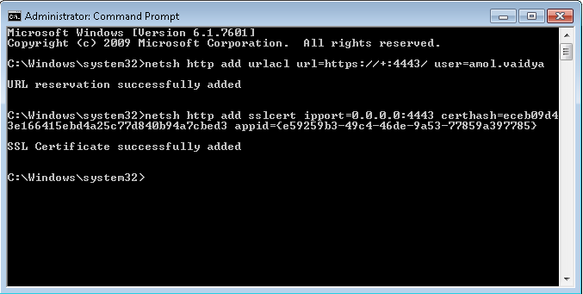

# Installation of PC configuration utility

This section explains the steps to be performed for installing PC configuration utility.

1. From the given setup files, open “setup.exe”. Click “Next >” for proceeding further.

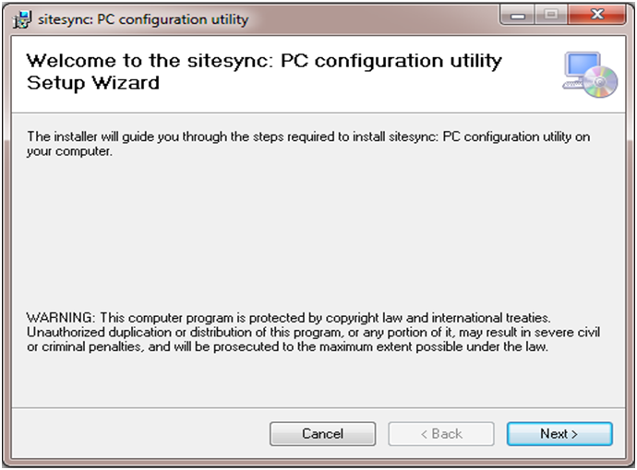

1. Select the folder where the PC configuration utility should get installed.

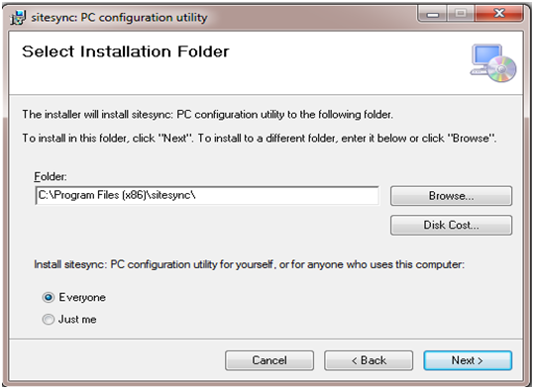

1. Click “Next >” for installing the utility.

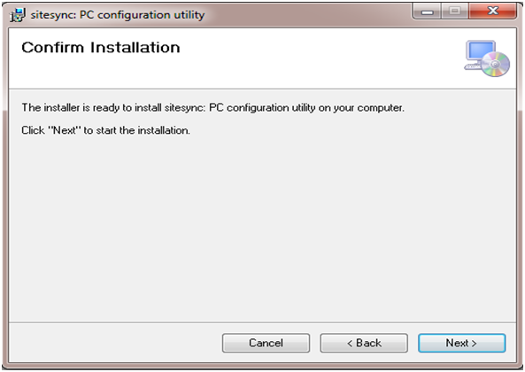

1. A dialog showing the installation progress will appear. Wait till installation completes.

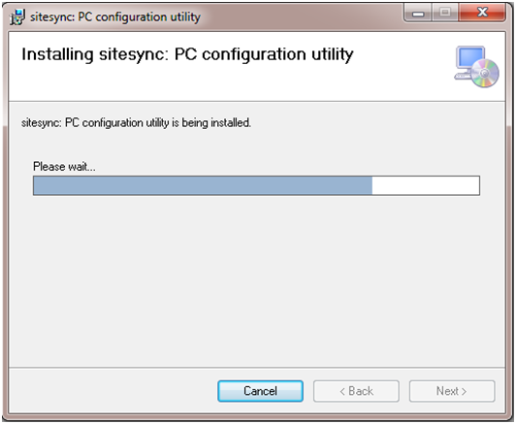

1. Installation process has been completed. Click “Close”.

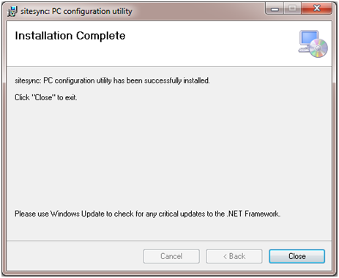

1. On the Desktop, shortcut with name “Sitesync PC configuration utility” has been created. Open shortcut for running the PC configuration utility.

